Use-Case Realization Report (Requirements)
System Maintenance

Issue 3.0
Revision History
Date | Issue | Description | Author
17 July 2000 | 1.0 | First Issue | Howard Russon
19 July 2001 | 2.0 | Revised for MTech Unit 3 in 2001 | Howard Russon
20 July 2004 | 3.0 | Revised for MTech Unit 3 in 2004 | Howard Russon

Table of Contents
1. Brief Description 4
2. Flow of Events 4
2.1 Standard Flow 4
2.1.1 Log-In 4
2.1.2 User Functions 4
2.1.3 Log-Out 5
2.2 Exceptions 5
3. Interaction Diagrams 5
3.1 Domain Collaboration Diagram: System Maintenance 5
4. Participating Objects 6
5. Class Diagrams 7
5.1 Domain Class Diagram: System Maintenance 7
6. Derived Requirements 7

Use-Case Realization Report
System Maintenance

Brief Description
The use case enables the Maintainer to perform vending machine maintenance tasks. The Maintainer will be able to monitor the stock levels of brands and coin denominations, view/change the prices of brands and remove all the coins from the vending machine.

Flow of Events
The standard flow of events for this use case and any exceptions are described in the following subsections. See section 3.1 for an overview of the participating Actors and Domain Objects.

Standard Flow
This use case provides the user interface related functionality that will be provided to the Maintainer in the real vending machine, as follows:

Log-In
To commence using the system, the Maintainer is required to log-in as follows:
- The Maintainer is required to enter a valid password into the Maintenance Panel.
- The system will check that the entered password is valid.
- If the password is invalid then the caption “Invalid Password” will be highlighted on the Maintenance Panel.
- If the password is valid (ie: the Maintainer has successfully logged-in), then the following will occur:
- The caption “Valid Password” will be highlighted on the Maintenance Panel.
- The status of the Door will set to unlocked. In the real vending machine, this will allow the Maintainer access to re-stock the machine.
- The new Door state will be displayed on the Simulator Control Panel.
- The current customer transaction (using the Customer Panel) will be terminated, and further Customer transactions will not be permitted while the Maintainer is logged-in.
- The Simulator Control Panel will be activated to permit data entry (so that the stock levels can be changed and the Door can be locked).

User Functions
If the Maintainer logs-in successfully, then the following functions are available to the maintainer:
- The Maintainer will be able to view the number of coins of each denomination held by the machine as follows:
- There will be a set of buttons below the caption “Quantity of Coins Available”, displayed vertically, representing each coin denomination held by the machine.
- If one of these buttons is pressed then the number of coins held in machine, corresponding to the denomination of the button, will be displayed in a panel to the right of the buttons.
- The Maintainer will be able to view the number of cans of each brand held by the machine, and also view and change the price of each brand as follows:
- There will be a set of buttons below the caption “Quantity of Drinks Available”, displayed vertically, representing each drinks brand held by the machine.
- If one of these buttons is pressed then the number of cans held in machine, corresponding to the brand of the button, will be displayed in a panel to the right of the buttons.
- In addition, the price of the selected brand will be displayed next to the caption “Brand Price”.
- The price of the currently selected brand will be able to be changed by entering a new price, in Singapore cents, into the text field to overwrite the current price displayed.
- The new price will then be stored.
- The Maintainer will able view the total amount of cash held by the machine as follows:
- The total amount of cash held within the machine shall be displayed by pressing the button with the caption “Show Total Cash Held”.
- The total cash will then be displayed next to the button.
- The Maintainer will be able to collect all money held in the Cash Store. This is achieved by using use case Transfer All Cash.

Log-Out
- The Maintainer will terminate use of the maintenance panel (ie: log-out) by pressing a button with the caption “Press Here when Finished”. If the state of the vending machine door is locked, then the log-out request will be successful and the maintenance panel will become inactive (ie: the functions can not be used) except for the “Password” text field. However, if the state of the vending machine door is unlocked, then the log-out request will be ignored.
- If the log-out request is successful then the following will occur:
- The Customer Panel will be updated to reflect changes in drinks brand prices, drinks brand availability and change availability.
- Customer transactions, using the Customer Panel, will be permitted to resume.
- The Simulator Control Panel will be deactivated (ie: data entry into the panel will not be permitted).

Exceptions
The following exceptions have been identified:
- Door Not Locked. If the vending machine Door is un-locked then the Maintainer is not permitted to formally log out from the Maintenance Panel. Note that in the computer simulation, the Door is locked by using the Machinery Simulator Panel.

Interaction Diagrams

Domain Collaboration Diagram: System Maintenance
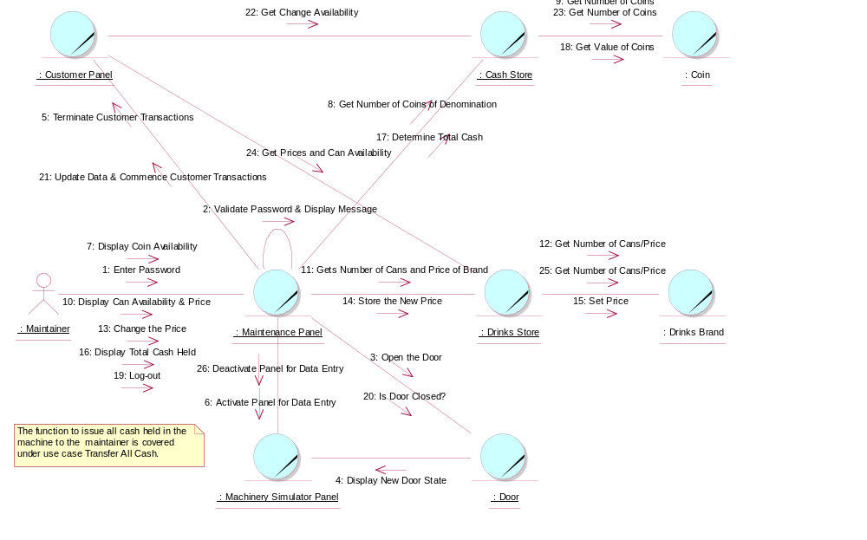

Participating Objects
: Cash Store
This is the repository for all Coins entered into the system. It is also where all change given to the Customer is taken from.
: Coin
The object stores the characteristics of coins entered into the system.
: Customer Panel
This panel simulates the vending machine's customer interface panel. It will enable the user (the Customer) to:
1 insert coins;
2 select brands;
3 terminate transaction.
It will also provide the following display functions:
1 display total money inserted;
2 indicate coin not valid;
3 indicate no change available;
4 display the value of the change to be collected;
5 display an icon representing the dispensed drink.

: Door
This is the door of the vending machine. This is opened so that the Maintainer can re-stock the machine.
: Drinks Brand
This object stores the characteristics of the types of drinks can held in the system.
: Drinks Store
This is the repository for the drinks cans held by the system.
: Machinery Simulator Panel
This panel simulates the physical actions of the maintainer. It enables the user to:
1 display and enter new values for the number of cans of each Drinks Brand held by the Drinks Store;
2 display and enter new values for the number of Coins of each denomination held by the Cash Store;
3 display whether the vending machine Door is unlocked, and enable it to be locked.

: Maintainer
This actor represents the vending machine maintainer who will have a simple display panel to enable stock levels of drinks-cans and change to be monitored, and to enable cash within the machine to be collected.
: Maintenance Panel
This panel simulates the vending machines maintainer control panel. It will enable the user (the Maintainer) to:
1 log-on using a password;
2 display number of Coins of each denomination in the Cash Store;
3 display total value of cash in the system;
4 display number cans of each Drinks Brand held in the Drinks Store;
5 change the price of any Drinks Brand;
6 collect all cash held in system;
7 formally exit from the panel.

Class Diagrams

Domain Class Diagram: System Maintenance
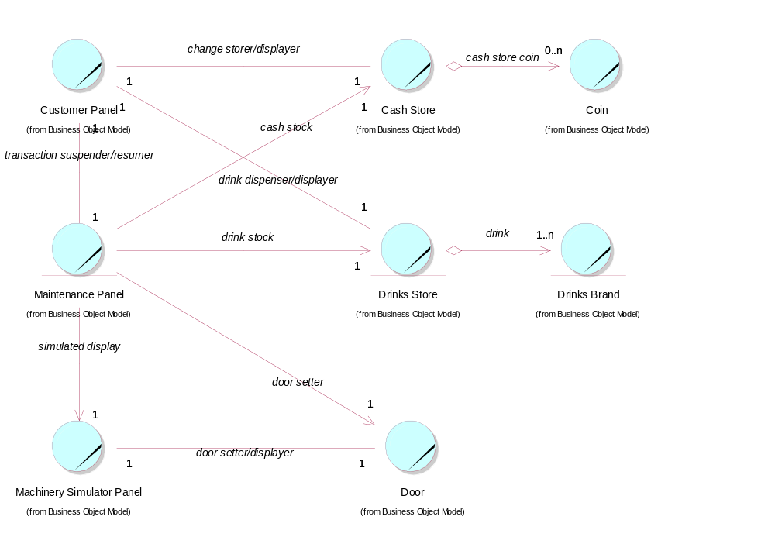

Derived Requirements
In the real vending machine, the Maintenance Panel must be equipped with a numeric key pad to enable the password and new Drinks Brand prices to be entered. In the computer simulation, the PC keyboard will be used.

